

Saira Kousar
55503
BSCS – VI
CC Lab # 04

Task # 01
Source code:
#include <iostream>
using namespace std;

int main() {
string s;
cout << "Enter binary string: ";
cin >> s;

int state = 0; // q0

for(char c : s) {

switch(state) {

case 0:
if(c == '1')
state = 0;
else if(c == '0')
state = 1;
else {
cout << "Invalid character";
return 0;
}
break;

case 1:
if(c == '0' || c == '1')
state = 1;
else {
cout << "Invalid character";
return 0;
}
break;
}
}

if(state == 1)
cout << "Accepted (matches RE)";
else
cout << "Rejected (does not match RE)";
}
Output:
If regular expression is : 1.(1)*.0

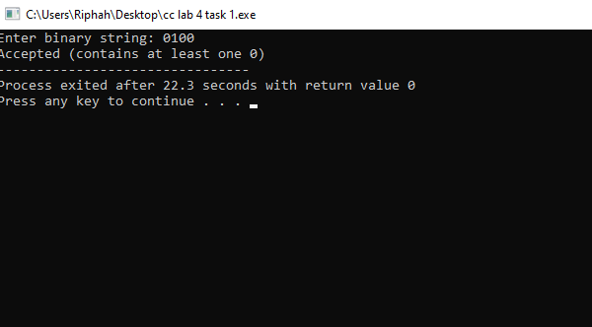
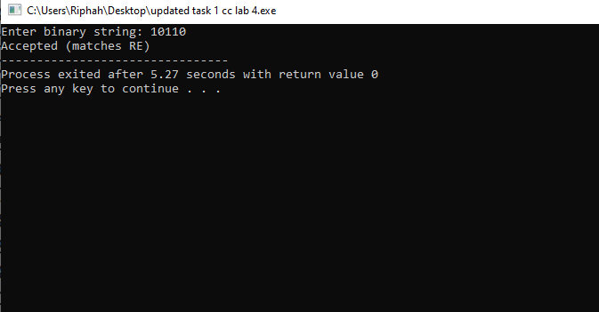
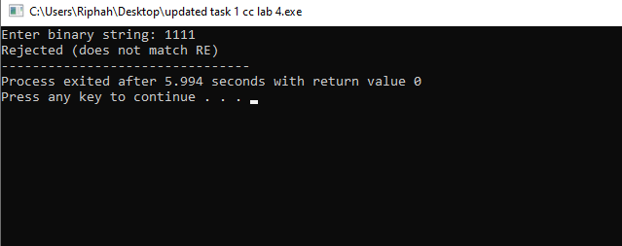
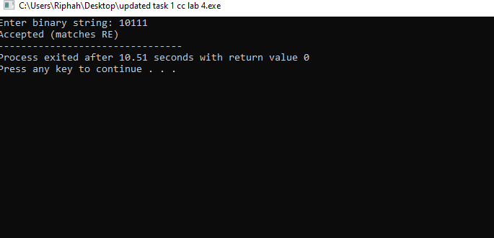
Task # 02
Source code:
#include<iostream>
using namespace std;

int main() {
string s;
cin >> s;

int state = 0;

for (char c : s) {
if (state == 0) {
if (c == 'a') state = 1;
}
else if (state == 1) {
if (c == 'b') state = 2;
else state = 1;
}
else if (state == 2) {
if (c == 'b') state = 3;
else state = 1;
}
}

if (state == 3)
cout << "Accepted";
else
cout << "Rejected";
}
Output:

